Network Perimeter Lab
CYBR3010
Cybersecurity Foundations

Arr Domingo
Student ID: 200458099
December 2025

Instructor: Sam El-Awour
Table of Contents
1 Introduction 1
2 Network Diagram 1
3 Build Windows Server (Domain Controller) Environment 2
3.1 Implement AD Directory Services 2
Task 3.1.1 Download and Install Windows Server 2
Task 3.1.2 Build and Configure a New Virtual Machine 3
Task 3.1.3 Prepare Server for Active Directory 7
Task 3.1.4 Install Active Directory Domain Services 11
Task 3.1.5 Promote Server to a Domain Controller 15
3.2 Centralized Network Authentication 20
Task 3.2.1: Prepare Windows 10 Client 20
4 Install FSSO_Setup (Fortinet Single Sign On) on the Windows server 2019 in VMWare to associate firewall and domain controller 21
Assuming FSSO_Setup is downloaded in local machine, to transfer files from local PC (host) to a Windows server VM in VMware Workstation Pro 21
Question and Answer 23
4.1 What is meant by “network perimeter defense” in modern enterprise networks? Explain how the traditional concept of a perimeter has evolved with cloud adoption, remote work, and mobile devices. 23
4.2 Compare the capabilities of a Next-Generation Firewall (NGFW) with those of a traditional Layer 3/4 firewall. Highlight features such as application awareness, intrusion prevention, SSL inspection, and user-based policies. 24
4.3 How can NGFWs leverage threat intelligence feeds for proactive defense? Discuss the potential benefits and risks of relying on third-party threat intelligence in firewall policy decisions. 25
4.4 How can NGFW policies support a Zero Trust security model? Explain how concepts such as micro-segmentation, least privilege, and continuous verification can be applied at the perimeter level. 26
References 1

1 Introduction
This document is about network security after a merger or acquisition which emphasize the use of firewall to protect the internal network and create demilitarized (DMZ) zone for public-facing services. The purpose is to set-up security measures in a computer network, how the network operates, protocols, standards, security considerations, and the prototypes associated with a range of networking technologies. Additionally, this document will configure and install an integrated, real-time and attack prevention using a virtual firewall appliance.
The purpose is to design a secure and efficient networked system, implement and examine advance networking security principles, networking devices, their protocols, and operations.

2 Network Diagram
This is the network layout which consist of virtual firewall, Windows server virtual machine with AD DS role installed, virtual network switch, and three client virtual machines representing different departments such as Engineering, Finance, and HR.
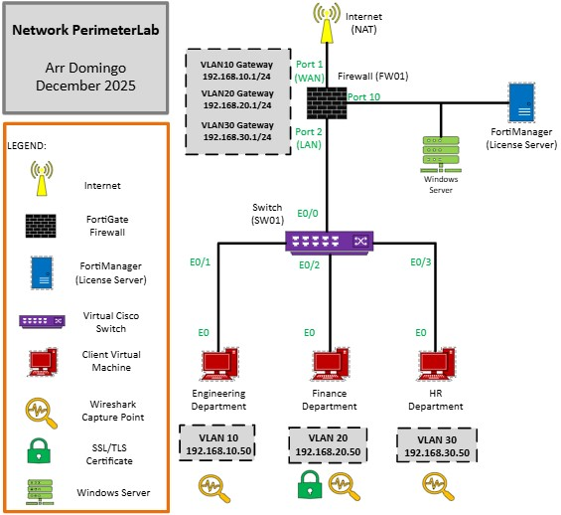
Figure 1. Network diagram of network perimeter lab.

3 Build Windows Server (Domain Controller) Environment

3.1 Implement AD Directory Services

Task 3.1.1 Download and Install Windows Server
- Download Windows Server 2019 Standard edition from the following website: https://aka.ms/devtoolsforteaching.
- Log in using your NAIT account.
- On the left panel, click on Software and search for "Windows Server".
- Download the Windows Server 2019 Standard edition. Remember the product key that will be generated using the “View key” button on the page.

Task 3.1.2 Build and Configure a New Virtual Machine
- Open VMware Workstation Pro. Go to File and click “New Virtual Machine”.
- Select “Typical (recommended)” and click Next.
- Choose “I will install operating system later” and click Next.
- For the O/S, select “Microsoft Windows” and pick “Windows Server 2019” from the drop-down menu. Click Next.
- Enter a virtual machine name and store it in a memorable location. Click Next.
- Keep the default disk size and click Next.
- Click Finish.
- Click “Edit virtual machine settings”.
- Set the RAM to 4GB (4096 MB).
- On the left menu, click “CD/DVD (SATA)”.
- Select “Use ISO image file” and then click on Browse and select the ISO file you just downloaded.
- Then click on OK.
- You will be brought back to the main windows of VMware Workstation Pro. Click on “Power on this virtual machine” to begin the installation process.
- In the Windows Setup window, click Next.
- Click on Install Now.
- Type the product key, then click on Next.
- Select “Windows Server 2019 Standard (Desktop Experience)” then click Next.
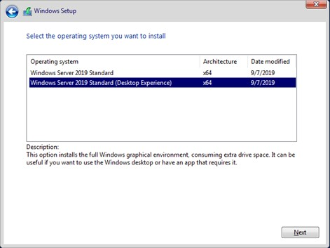
Windows Server 2019 Standard (Desktop Experience) as the operating system.
- Accept the license agreement, then click on Next.
- Select the second option for Custom: Install Windows only (advanced).
- Click on Next to select the entire disk space to install the O/S.
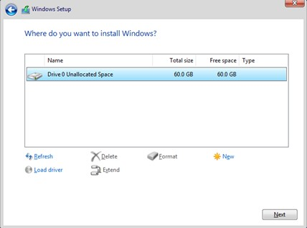
Disk space configuration.
- The installation will now be underway.
- Type a memorable password (qwerty01A.SERVER2019) for the built-in administrator account, then click on Finish.
- Log in to the server.
- If you see a message about allowing your PC to be discoverable, click Yes.
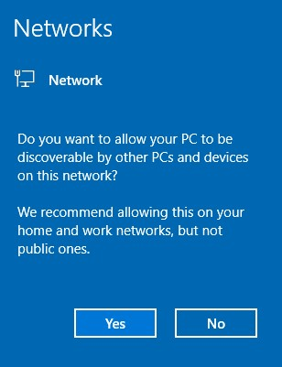
Allowing PC to be discoverable.
- In the Server Manager pop-up message, click on Don’t show this message again and then close the window.
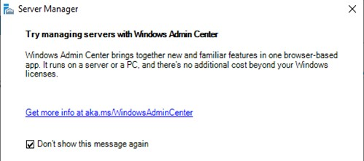
Server Manager message.

Task 3.1.3 Prepare Server for Active Directory
- Install VMTools by going to VM menu then click “Install VMware tools”.
- A message will appear on VMWare screen or just go directly to D drive and look for the setup application. Run the setup and keep default. Restart the server.
- After you log in, the server manager dashboard will open automatically.
- On the left panel, click on Local Server, then click on the computer name. Let’s change it to SRV01.
- Click on Change.
- Type SRV01 and then click OK.
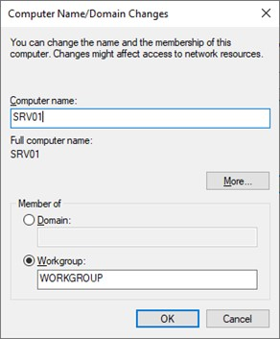
Set computer name to SRV01.
- A message will appear indicating a restart is needed. Click OK.
- Click on Close in the System Properties window.
- Finally, click on Restart Now.
- Log in to the server, open the command prompt, and find out your IP address, subnet mask, and default gateway. Make a note of this information.
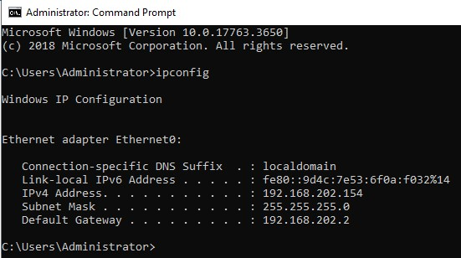
IP configuration of the server.
- Back on the Server Manager dashboard, click on Local Server on the left panel, then click on Ethernet0 to set up a static IP.
- Right-click on Ethernet0 and select Properties.
- Disable IPv6 to avoid communication issues. Select IP version 4, then click on Properties.
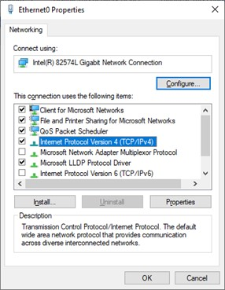
Ethernet0 properties.
- Set a static IP based on the information you noted. The static IP in the example is 192.168.202.154, but yours might be different. Make sure you set the preferred DNS server to the same as the static IP server because DNS will be installed on the same server. Click OK, then click Close.
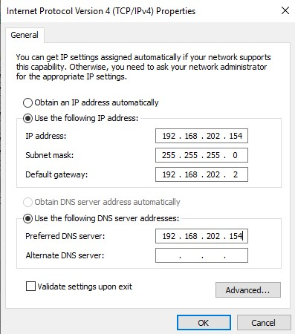
Set static IP.
- Back on the Server Manager Dashboard, refresh (F5), and you will notice the static IP.
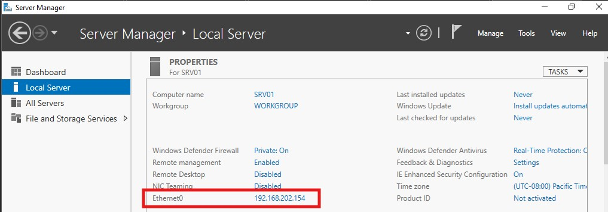
Confirmation of static IP had been set-up.
- Now the server is ready for Active Directory to be installed.

Task 3.1.4 Install Active Directory Domain Services
- On the top right corner of the server manager dashboard, click on Manage > Add Roles and Features.
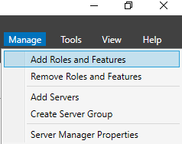
Add Roles and Features.
- Click Next on the "Before you begin" screen.
- Click Next to select "Role-based or feature-based installation".
- Click Next again.
- Select the second option, Active Directory Domain Services.
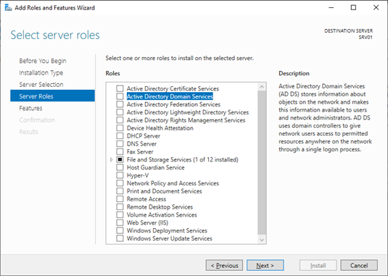
Selecting active directory domain services.
- In the pop-up message, click on Add Features.
- Click Next.
- Do not select additional features. Click Next.
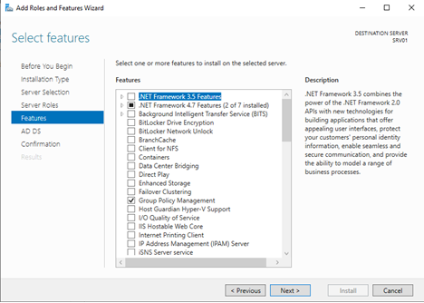
No additional features, just click next.
- The Directory Service installation will begin. Click on Next. Click on Restart the destination server automatically if required. You will see a warning message, click Yes.
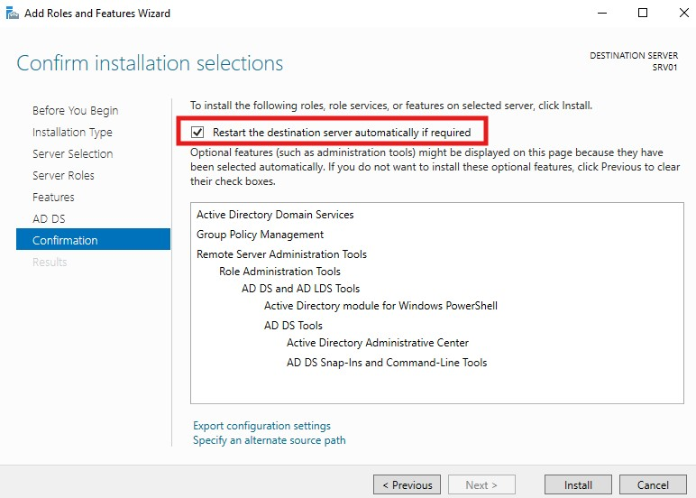
Restart the destination server automatically.
- Then click on Install.
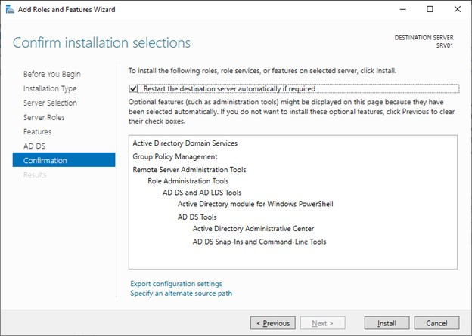
Click install.

Task 3.1.5 Promote Server to a Domain Controller
- When the installation of Directory Services is over, click on Promote this server to a domain controller.
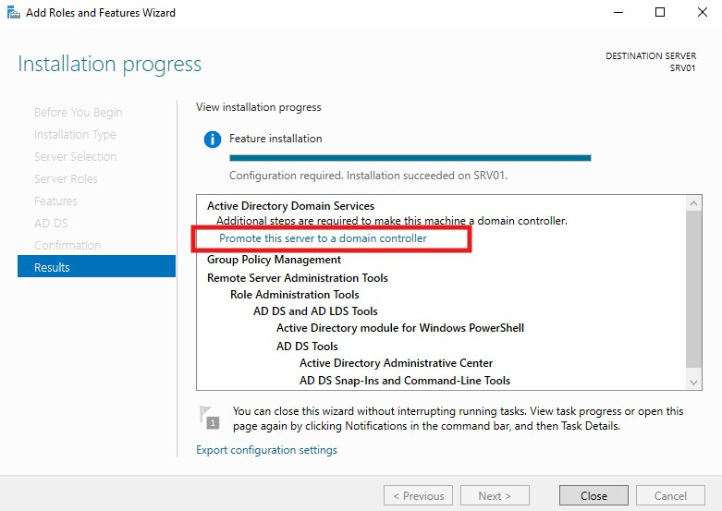
Promote server to a domain controller.
- Another setup window will appear. Click on Add a new forest and set the root domain to “domingo.com”. Click Next.
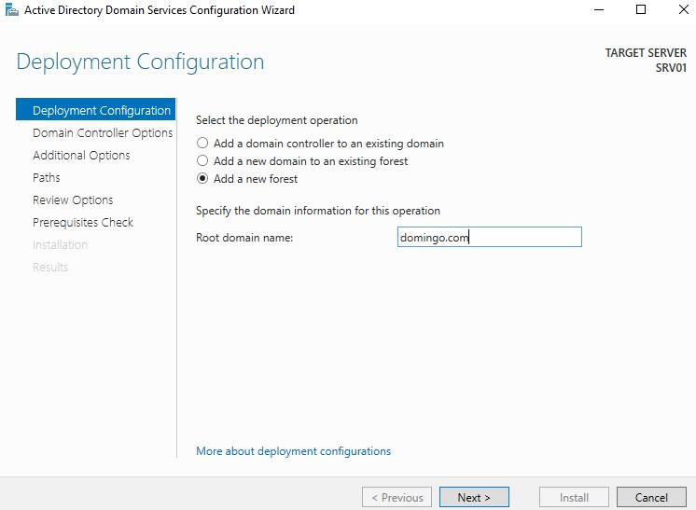
Root domain name.
- Set the recovery password (P@ssword01) twice to something memorable, then click Next.
- You will see a warning message indicating that a DNS zone was not found. Click Next, and it will be installed automatically.
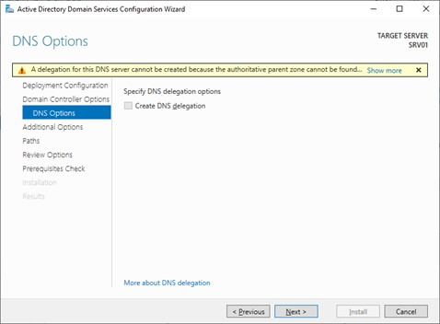
Warning message.
- The NetBIOS name will be populated automatically. Click Next.
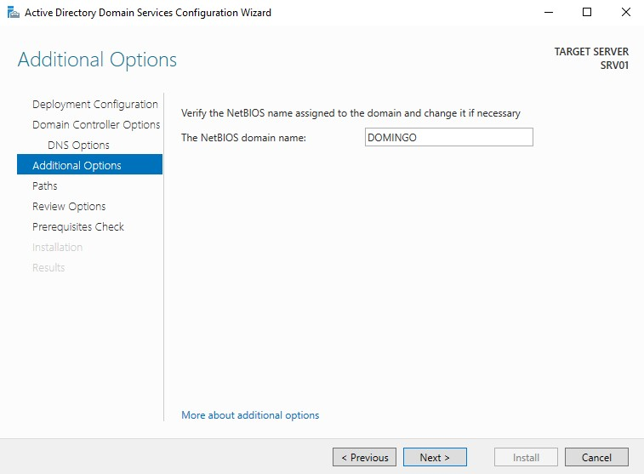
NetBIOS domain name will be populated.
- The location of the Active Directory database and log file will be displayed. Click Next.
- Click Next on the Review Options screen.
- Finally, click on Install.
- When the installation is over, the server will restart automatically. This might take a while.
- Log in to the admin account. The local administrator has now become a domain administrator and can access and administer any computer that is joined to the domain. Use the password you set-up in Task 3.1.2 (qwerty01A.SERVER2019).
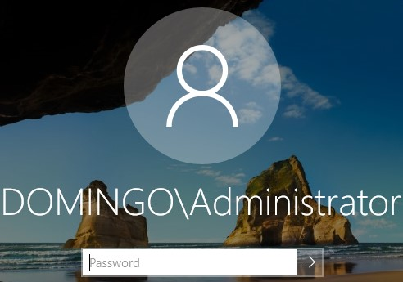
Domain administrator.
- The Server Manager dashboard will open. Click on Tools > Active Directory Users and Computers.
- We will use AD Users and Computers to create domain users (network accounts) that can be used by employees to log in to their Windows 10 machines that are joined to Active Directory.

3.2 Centralized Network Authentication

Task 3.2.1: Prepare Windows 10 Client
1. Power on the Windows 10 OS and log in using your local admin account. First, we must change the computer name and set a static IP before joining the client to the cyber.com domain.
2. Open File Explorer, right-click This PC, and select Properties.
3. Click on Rename this PC.
4. Type DESKTOP01, then click Next.
5. Click on Restart now for the change to take effect.
6. Log in to the computer and open the command prompt to find out the IP address, Subnet Mask, and Default gateway.
7. Let’s set up a static IP. Find the ethernet adapter, then right-click on Ethernet0 > Properties.
8. Disable IPv6 to avoid any communication issues, then click on IPv4, then click on Properties.
9. Set the IP address based on the information you obtained from the command prompt. In this case, the static IP is 192.168.202.165. Make sure you set the preferred DNS to the IP address of Active Directory since DNS is part of it. Click OK when you finish.
10. Click Close.

4 Install FSSO_Setup (Fortinet Single Sign On) on the Windows server 2019 in VMWare to associate firewall and domain controller

4.1 Assuming FSSO_Setup is downloaded in local machine, to transfer files from local machine (host) to a Windows Server 2019 VM in VMware Workstation Pro
- Install VMware Tools: In your running VM, go to VM > Install VMware Tools. Run the installer inside the Windows Server guest and reboot if prompted.
- Enable Guest Isolation: In Workstation, go to VM > Settings > Options > Guest Isolation. Check "Enable copy and paste" and "Enable drag and drop".
- Configure Shared Folder in VM:
  - Go to VM > Settings > Options > Shared Folders.
  - Select "Always enabled" and click "Add" to choose a host folder to share.
  - Grant permissions (read-only or read/write).

- Configure Shared Folder in local machine (host):
  - Right-click the folder you want to share, click Properties.
  - Go to Sharing tab and click Advanced Sharing.
  - Enable the Share this folder. Click OK then Close.
- Access in VM: The shared folder appears as a network drive (e.g., \\vmware-host\Shared Folders) in your Windows Server VM.

4.2 Access the FSSO_Setup in the shared folder and install
- Open a file explorer, paste “\\vmware-host\Shared Folders” and press enter.
- The shared folder must be there. Navigate to the FSSO_Setup file and click Run.
- Click Next.
- Accept the terms and click Next.
- Click Next.
- Input the User Name which must be in the form of DomainName\Username (DOMINGO\Administrator) and Password which is the password of the Windows Server 2019. Click Next.
- Keep default and click Next.
- Click Install.
- Click Finish.
- Fortinet Single Sign On Agent window will open, just click Next.
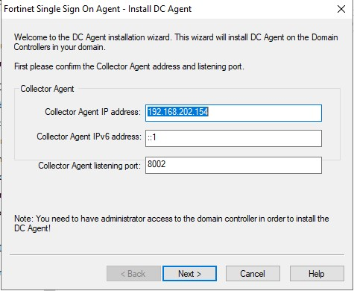
- Select domain and click Next.
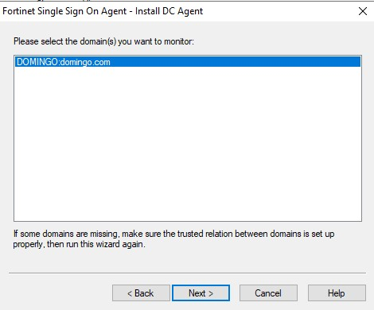
- Keep the default and just click Next until installation is finished.

4.3 Open the Fortinet Single Sign On window
- Click the Windows icon and type “Fortinet”.
- Click “Configure Fortinet Single Sign On Agent”.
- Make sure that you configure a password and the “Collector Agent Status” should be set to “RUNNING”.
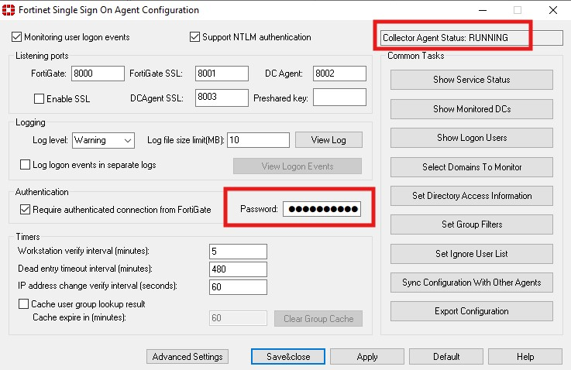
User interface of FSSO (Fortinet Single Sign On).
- If the “Collector Agent Status” is set to NOT RUNNING, click Windows icon and type “Services”.
- Navigate through “Fortinet Single Sign On Agent Service”.
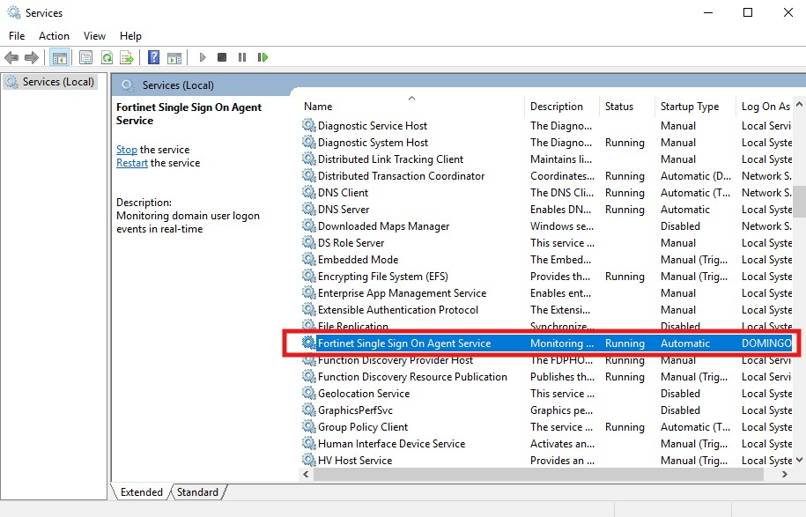
Check “Services” in case FSSO is not running.
- Double-click “Fortinet Single Sign On Agent Service”. On the “General” tab, press “Start”. On the “Log On” tab, enter the domain administrator and password.
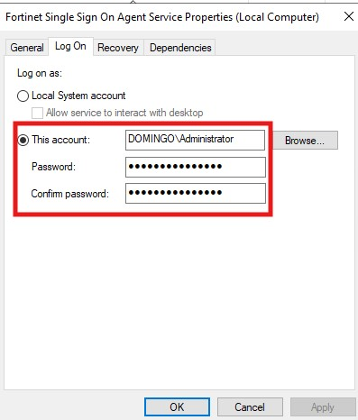
Check Log On tab.
- Let “Fortinet Single Sign On Agent Configuration” run in the background.

Question and Answer

4.1 What is meant by “network perimeter defense” in modern enterprise networks? Explain how the traditional concept of a perimeter has evolved with cloud adoption, remote work, and mobile devices.
Network perimeter defense refers to security measures that protect an organization’s internal network from external threats by controlling traffic at the network boundary. Traditionally, this involved firewalls, intrusion detection/prevention systems (IDS/IPS), and VPNs which monitor and control traffic entering or leaving the network.
The traditional network perimeter, once a clearly defined boundary protected by firewalls, has dissolved due to cloud adoption, remote work, and mobile devices. It has been replaced by a dynamic, identity-centric approach that operates on the principle of "never trust, always verify," known as the Zero Trust security model. Unlike traditional security models that assume everything inside the perimeter is safe, ZTA treats every user, device, and application as untrusted by default, whether inside or outside the network.

4.2 Compare the capabilities of a Next-Generation Firewall (NGFW) with those of a traditional Layer 3/4 firewall. Highlight features such as application awareness, intrusion prevention, SSL inspection, and user-based policies.
A Next-Generation Firewall (NGFW) extends security to the application layer (Layer 7) through deep packet inspection and application awareness, allowing organizations to identify and control applications regardless of port or protocol. NGFWs integrate intrusion prevention systems (IPS) for real-time threat detection, support SSL/TLS decryption and inspection to uncover hidden threats and enable user-based policies by linking rules to user identities or groups rather than just IP addresses. Additionally, NGFWs leverage real-time threat intelligence for proactive defense against modern attacks like malware and ransomware, making them significantly more effective in today’s dynamic network environments.
On the other hand, a traditional Layer 3/4 firewall primarily provides packet filtering and stateful inspection based on IP addresses, ports, and protocols. It lacks visibility into application-layer traffic and cannot enforce granular controls beyond basic network parameters. These firewalls do not include integrated intrusion prevention, rely on separate IDS/IPS solutions, and cannot inspect encrypted SSL/TLS traffic. Policies are typically IP-based, offering no user identity awareness

4.3 How can NGFWs leverage threat intelligence feeds for proactive defense? Discuss the potential benefits and risks of relying on third-party threat intelligence in firewall policy decisions.
Next-Generation Firewalls (NGFWs) leverage threat intelligence feeds to enhance proactive defense by integrating real-time data on malicious IPs, domains, URLs, and attack patterns into firewall policies. These feeds, sourced from global threat intelligence platforms, allow NGFWs to automatically update rules and block emerging threats before they exploit vulnerabilities.
Benefits include faster detection of evolving threats, automated policy updates, and improved accuracy in blocking malicious traffic, which collectively strengthen an organization’s security posture. However, risks exist such as reliance on third-party intelligence that disrupt legitimate traffic, create dependency on external providers, and raise concerns about data integrity and trustworthiness of the feed. Misconfigured integrations or outdated feeds may also lead to gaps in protection or unintended blocking of critical services.

4.4 How can NGFW policies support a Zero Trust security model? Explain how concepts such as micro-segmentation, least privilege, and continuous verification can be applied at the perimeter level.
Next-Generation Firewall (NGFW) policies can significantly support a Zero Trust security model by enforcing granular controls at the network perimeter. Zero Trust operates on the principle of “never trust, always verify,” requiring continuous authentication and authorization for every user, device, and application. NGFWs enable this by applying identity-based policies, integrating with authentication systems, and inspecting traffic at the application layer. They support micro-segmentation by creating secure zones within the network and controlling east-west traffic, which limits lateral movement of threats. NGFWs also enforce least privilege by allowing access only to specific applications and resources based on user roles and device posture. Furthermore, NGFWs facilitate continuous verification through real-time monitoring, behavioral analysis, and integration with threat intelligence feeds, ensuring that trust is dynamically reassessed rather than granted indefinitely. This combination of capabilities makes NGFWs a critical component for implementing Zero Trust at the perimeter and across hybrid environments.

References

A Guide to Perimeter Defense in Modern Networks. (2025, May 20). Retrieved from Fidelis Security: https://fidelissecurity.com/threatgeek/network-security/perimeter-security-and-defense/
Cooper, S. (2025, March 24). NGFW and Zero Trust Integration. Retrieved from comparitech: https://www.comparitech.com/net-admin/ngfw-zero-trust-integration/
Integrating Third-Party Threat Feeds into Firewalls. (n.d.). Retrieved from Q-feeds: https://qfeeds.com/integrating-third-party-threat-intelligence-into-firewalls/
Janeiro, R. (2024, November 1). Enhancing Network Security with Next-Generation Firewalls. Retrieved from On Call: https://nist800171compliance.com/enhancing-network-security-with-next-generation-firewalls/
Perimeter Security. (n.d.). Retrieved from Acalvio: https://www.acalvio.com/resources/glossary/perimeter-security/
What is Zero Trust Architecture (ZTA)? (n.d.). Retrieved from paloalto: https://www.paloaltonetworks.com/cyberpedia/what-is-a-zero-trust-architecture#:~:text=Zero%20Trust%20Architecture%20(ZTA)%20is,a%20highly%20distributed%20digital%20environment.
Why Network Security Will Never Be The Same. (2025, April 25). Retrieved from Forbes: https://www.forbes.com/councils/forbestechcouncil/2025/04/25/why-network-security-will-never-be-the-same/

